April 16, 2015
Rachel Golson
Precision Drilling Corporation
800, 525-8th Avenue S.W.
Calgary, Alberta, Canada T2P 1G1
Rachel,
In reference to your Global HCM Master Data project, C CUBED Data Integrators would like to offer the following planning phase proposal and statement of work for you to consider.

Included in this phase are the following activities:

- Develop the project plan
- Review the project plan with key stakeholders
- Develop a detailed execution plan
- Develop a resource plan for execution

Once the development of the detailed execution plan and resource plan is underway, we will provide a proposal for the subsequent execution and delivery phases of the work.
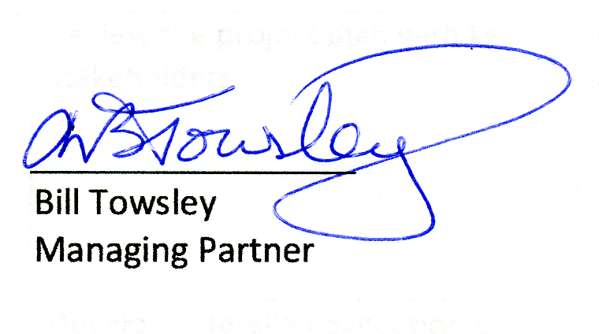

SCHEDULE “A”
Statement of Work

Client: | Precision Drilling Corporation
C CUBED DI Representatives: | Bill Towsley - Delivery Manager and SME  Chris Marko – Project Manager
Start Date: | 2015-04-20
End Date: | 2015-05-01

Activity | Description | Primary | Add'l
Develop the project plan | Utilize ASAP methodology in conjunction with any Precision Drilling project management requirements to develop a project plan for the Global HCM Master Data project.  Engage key Precision Drilling resources, as required, to ensure the resultant plan accurately reflects the requirement, timelines and constraints. | Chris Marko  20 hours | Bill Towsley  4 hours
Review the project plan with key stakeholders | Prior to developing a detailed execution plan, organize and facilitate a plan review with key stakeholders within IT, HR and the business. | Chris Marko  4 hours | Bill Towsley  2 hours
Develop a detailed execution plan | Working from the approved project plan, develop a detailed execution plan that is resource loaded. | Chris Marko  30 hours | Bill Towsley  2 hours
Develop a resource plan for execution | Utilizing the resource requirements from the detailed execution plan, develop a resource plan complete with the qualifications required to deliver activities within the detailed execution plan. | Chris Marko  26 hours | Bill Towsley  2 hours

Rates:

C CUBED Data Integrators would prefer to engage directly with Precision Drilling Corporation and these rates reflect that type of arrangement. Should C CUBED resources be required to engage through a third-party (e.g. SI Systems) then third-party overheads would be in addition to rates indicated below.

Chris Marko | Project Manager | $130/hr + GST
Bill Towsley | Master Data SME | $155/hr + GST
Bill Towsley | Delivery Manager | Included

