 | HCM Global HR Master Data
 | Author: | Rachel Golson, Karen Kerkhoff, Paul Sudzina | Program Sponsors: | Darren Ruhr
 | Date: | February 19, 2015 | Version: | 1.0

Project Background

The overarching vision for Human Capital Management at Precision Drilling is to deliver operational excellence, with skilled staff delivering services through the application of common business policies and processes enabled by a consistent suite of systems. Globally harmonized business processes call for a unified approach to management of our organizational and employee master data, taking into consideration localized business and regulatory requirements.

Master data teams currently reside in multiple functional areas including Payroll, Human Resources, and Personnel and have different standards in terms of what data is collected and how it is categorized in the system. The current business model is paperwork onerous and can result in handling delays impacting downstream systems and processes. Inconsistencies of requirements and process by company and poor data quality controls cause manual re-work and negatively impact the quality of data for reporting.

To address this issue, the Global HR Master Data Management initiative will deliver simplified, standardized, and common processes for HR data management encompassing People, Process, and Technology. The project will be delivered in four major streams of work, each of which will be aligned for delivery within the broader Human Capital program roadmap.

Project Definition

Project Objectives
Organizational and employee master data provides a foundation for Human Capital Management processes.
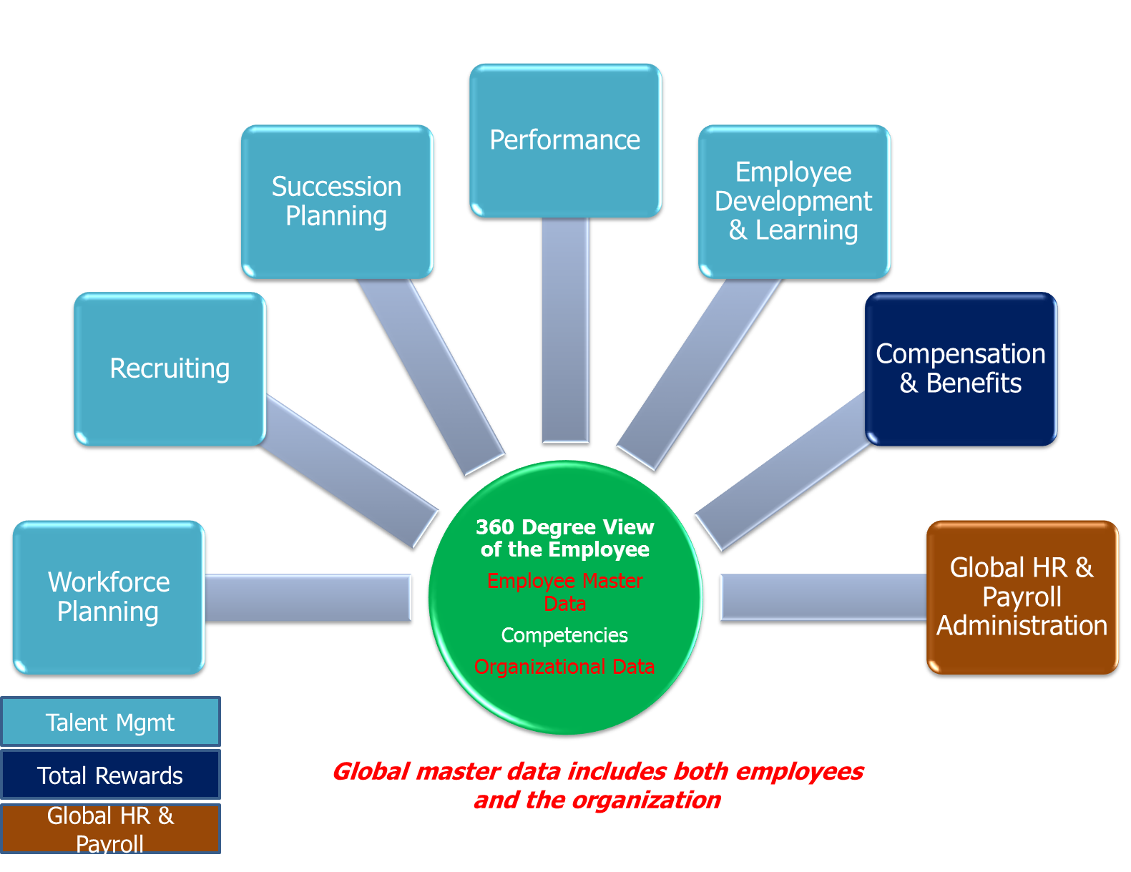

The primary goal of the Global HR Master Data Management project is to address existing and newly identified issues, eliminate the barriers, and implement the required changes to optimize and automate master data management processes through the use of our people, processes and data, while leveraging our current technology investments in SAP and SuccessFactors, and other data management tools over a multi-year timeframe.

Key Pain Points Across the Master Data Management Process
Reporting
Data Maintenance
Data Capture

Process & System Knowledge

Data Capture – Incomplete and/or inaccurate paperwork
- Current Status Change form is not tailored to the individual needs of each employee lifecycle event as such it is confusing for Managers to use as it is not clear what information is required for each scenario
- As there is limited training or reference material, accurate form completion is challenging for Managers
- Forms are not standardized between companies or countries

Data Entry
- Poor position “vacancy” management in SAP Organizational Management
- Challenge with inaccurate position attributes (i.e. job, pay grades) causing delays in entry and re-work
- High volume of exception scenarios that are not documented or easily managed within our current processes
- Processes are not standardized between companies or countries
- Corporate transfers, especially those between countries, are poorly understood and timing of transfer execution is not aligned between countries

Reporting
- Significant manual effort to cleanse data prior to producing reports (i.e. headcount and turnover)
- Current process and system design and tools do not enable clear and consistent capture of data required to support management reporting (i.e. termination reason codes)

Process and System Knowledge (People)
- Unclear definition of roles and responsibilities of process stakeholders (Managers, HR Business Representatives, Compensation, Benefits, HRIS and Payroll)
- Inconsistent definition of data maintenance ownership between countries
- Lack education on the ‘end to end’ process flow and how issues or work-arounds in one step impact downstream processes
- Lack visibility to the potential operational improvements that could be achieved through significant process change, standardization, and automation
- Limited training documentation on either process or system activities

Project Objectives

This project has the following objectives:
- Achieve improvements in operational excellence by creating consistency of employee processes and data across the company
- Improve efficiency, accuracy, and timeliness master data capture and system entry across the end to end process, beyond the bounds of technology
- Ensure that the improved master data process continues to facilitate the accurate and timely production of time evaluations, payroll results and general ledger entries and supports the financial reporting requirements of each business unit
- Deliver timely and accurate reports to meet regulatory and compliance requirements and Business needs
- Identify qualitative and quantitative goals to achieve operational excellence, with expected benefits and appropriate supporting metrics with baseline and target measures

The project will address the current business model from a holistic perspective, assessing:
- People – Do the resources involved in the process have the proper knowledge/skillset?
- Process – Does the process meet business requirements and have the right balance of controls vs. efficiency?
- Data – What are the key master data elements? By whom and how will these be maintained?
- Technology – Does the current technology support the business process?
- Strategy – What strategic elements are missing or can be improved to enhance the effectiveness of data management?
- Structure – Are there issues from an organizational perspective contributing to the pain points?

Critical Success Factors
The following factors have been deemed important to the success of this project and must receive special and continuing attention:

User Involvement and Ownership
- Users must be dedicated to the project and own its inputs and outcomes with representative participants across the end to end process and not just key designates in HR and Payroll
- The Global HR Master Data Project is a multi-year initiative, user adoption of each phase of the project is crucial. Due to the integrated nature of the roadmap, lack of adoption of one rollout will compromise the achievable benefits and success of subsequent project rollouts and the overarching program

Executive Management and HR/Payroll Leadership Support
- As significant behavioral change is expected, in addition to system additions and enhancements, executive support is crucial to support this transformation

Willingness to Drive and Adopt Change
- The continuous improvement approach for this project will deliver not only the end result of data standardization but also improved business processes. This is intended to be an ongoing activity transforming the way work is managed and issues are resolved. It is important to have the commitment from the stakeholder and management teams that this will be a part of daily operations going forward and will not end with project closure

Team Communication, Delivery Management, and Change Management
- Parallel work streams must communicate and update each other regularly – including Business, Change Management, Training, and SAP Support enabled by strong executive leadership and sound project management
- A key to the change management success will be to establish a foundation (baseline) then track and communicate the benefits to the business and the stakeholders through the lifecycle of the broader Program vs. separately by project

Assumptions
- Project Quality Has a Higher Priority Over Schedule and Cost
- To retain internal knowledge key Precision IT team members will be backfilled by consulting support
- The Precision enterprise master data governance and standards initiative will be approved

Project Scope
The Global HR Master Data initiative will be structured around four primary work streams, often with multiple initiatives in each work stream. The intention is deliver a series of impactful improvements to HR master data management aligned with the broader HR roadmap.

- Centralize – During this phase master data administration will be centralized reporting to the HRIS department with operations in three locations in Canada, the US, and International. Centralization is complete for the US and Canadian Master Data teams. It is expected International master data entry will be done in both the US and Canada, once the process has been determined and proper training has occurred.

- Standardize – During this phase a business process improvement assessment will evaluate and document the end to end business processes, forms, and technology used to manage HR master data. ‘To be’ globalized and standardized business processes will be developed. Improvement opportunities will be prioritized for delivery taking into consideration the ease of implementation and value delivered. Quick wins/short term improvements will be implemented in the existing SAP HCM module as soon as possible. Longer term opportunities will be incorporated into the broader HR program roadmap for delivery, aligned with projects such as the future SuccessFactors Employee Central Implementation.

- Automation – This phase will focus on automating portions of the HR master data administration processes, specifically the communication and interaction between Employees, Managers, HR professionals, and the HRIS organization. This initiative would leverage existing and new technologies to automate data capture, validation, and processing.

- Learning – Aligned with the work streams above, the Learning stream will develop and deliver training to achieve a more thorough understanding of the end to end process, individual user roles and how they affect others in the process; more consistent execution of the process steps and improved user adoption and satisfaction.

Centralizing Phase Scope:

The objective of the centralizing stream is to consolidate staff performing global HR master data administration to report to one department – HRIS.

- The dedicated master data team under payroll (6) and Human Resources was centralized under the HRIS department creating a global master data team
- Current Canadian structure under includes3 Master Data Administrators
- Current U.S. structure includes 1 Team Lead and 2 Master Data Administrators
- Current U.S. structure under Human Resources includes 5-7 HR representatives in the field with shared responsibilities.
- Analysis of workload will be required to determine appropriate staffing levels once centralization, standardization, and automation are in place.
- Current International structure includes 3-4 HR representatives in the field with shared responsibilities. Analysis of workload will be required to determine appropriate staffing levels to accommodate the completion of the centralization of the International Master Data team. The location of this team will be dependent upon where International Payrolls will be processed.
- Creation of a new role “HRIS Supervisor” to lead global master data team was implemented January 1, 2015 in the Houston office ,reporting to HRIS

Standardizing Phase Scope:

The objective of the standardizing stream is to develop a consistent set of global HR master data processes and data standards, taking into consideration localized business and regulatory requirements. End to end processes of data entry for all employee transactions will be reviewed, enhanced and reconfigured for global support.
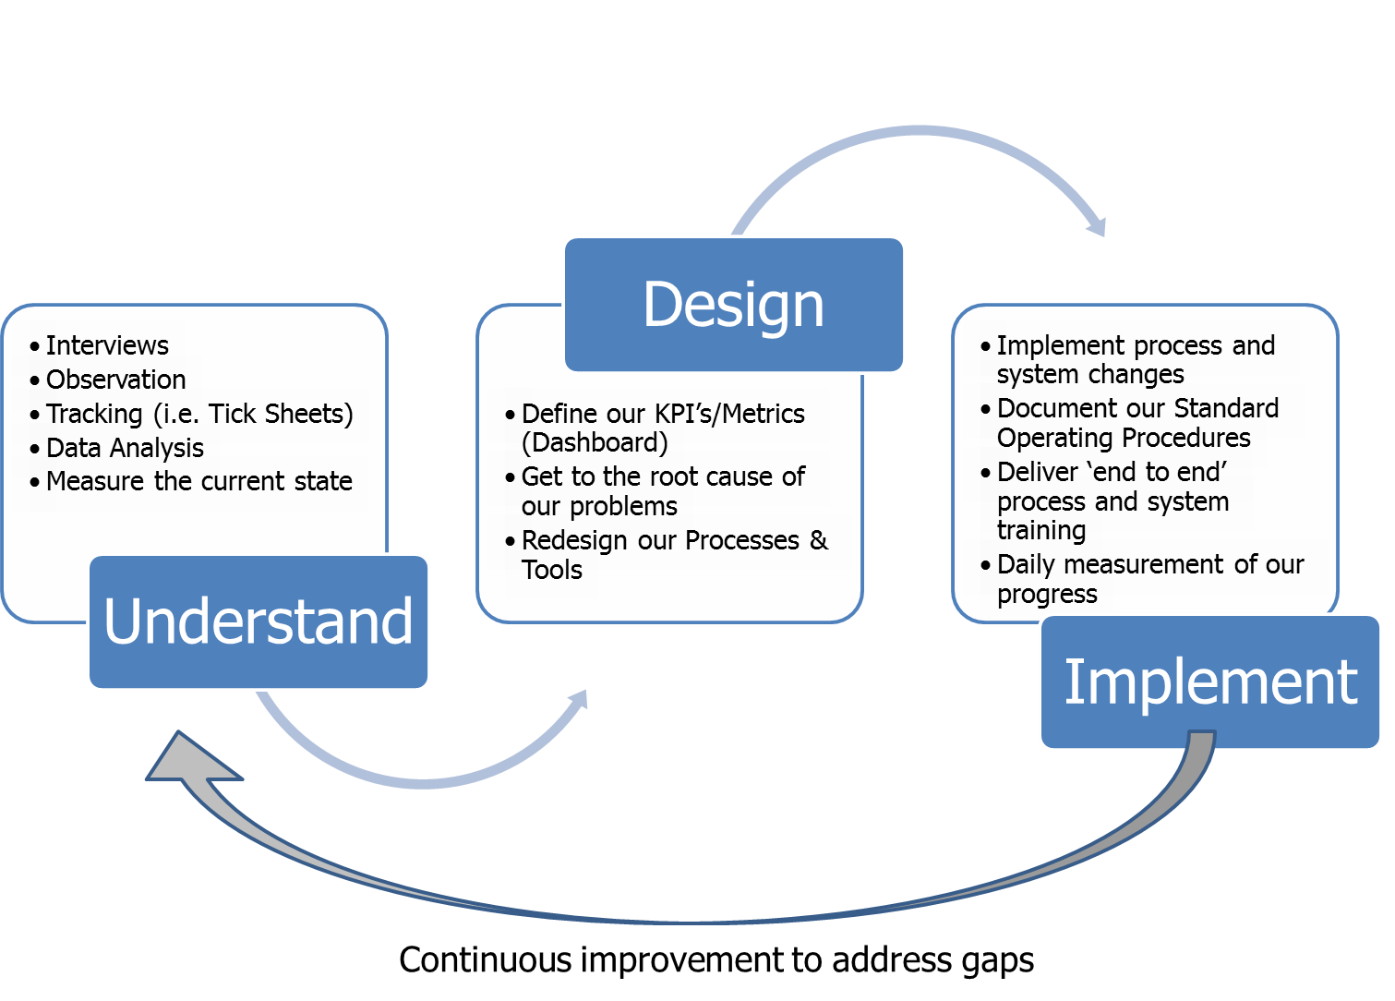
Part 1 – Global Master Data Design
- This initiative will develop a strategy and plan to enhance employee master data content and structure, aligned with the broader enterprise master data governance and standards
- The current business processes will be documented and pain points identified, classified as People, Process, Technology, Data and Structure.
- This assessment will be broad in nature evaluating the lifecycle of employee data across all stakeholders involved in the process and provide detailed insight into ‘A Day in the Life Of’ HR master data administration. The goal will be identification of process, training, and technology improvements to materially enhance the HR master data management processes, global data standardization requirements, and data integrity.
- The outcome of this initiative would be a clearer understanding of the master data processes, the roles and responsibilities of the various personnel included in the processes, and better documentation of these processes.
- Based on output from the process assessment, improvement opportunities will be prioritized for delivery taking into consideration the ease of implementation and value delivered. Quick wins/short term improvements will be implemented in the SAP HCM module as soon as possible. Longer term opportunities will be incorporated into the broader HR program roadmap for delivery.

Part 2 – Global Master Data Implementation
- The following organizational master data elements will be included in scope:
  - Organizational Units (departments) and their relationships to Finance company codes and cost centres
  - Positions and their attributes (i.e. enterprise structure assignment)
  - Jobs and their attributes (i.e. compensation structure assignment)
  - Reporting relationships – resolve the issue of manager definition. In the current state there are three different ‘manager’ definitions: chief (manager) vs. reports to (supervisor) vs. compensation planning manager (custom design)
- In order of priority, the following employee transactions will be part of the business process improvement
  - Offboarding: Termination and Termination Field – global standardization in progress
  - OnBoarding: Initial Hire, Hire and Re-Employ – global standardization in progress within onboarding project
  - Assignment Changes: Promotions, Demotions, Transfers within Country and Global
  - Salary Changes
  - Operational Movements: Layoff/Furlough and Return from Layoff Furlough
  - Leave of Absence: LOA and Return from LOA

- An assessment of current configuration will be part of each transaction review. Testing and potential reconfiguration may be in scope depending upon findings.
- Interfaces will be assessed and tested for potential issues.
- Forms will be reviewed and redesigned to simplify and standardize data capture, while making appropriate accommodations for regional or contractual requirements
- Current reporting will be assessed and aligned to leverage the new global standards. Gaps in existing reporting on master data will be identified and prioritized. Pending scope of reporting requirements, a separate initiative maybe recommended (i.e. to support management dashboard KPI’s and metrics)

Automation
The objective of this stream is to automate portions of the employee lifecycle processes that are standardized and repeatable. This initiative would leverage existing technologies inherent in SAP and SuccessFactors along with new data management technologies such as WinShuttle. WinShuttle is an SAP partner tool that enables data loading from external forms, with process validations, into SAP.

Although it is expected that the SuccessFactors solution will be the technology foundation for the subsequent transforming Human Capital initiatives; automation technologies could be piloted to understand and assess the impact on process and people in advance.

For example, although the configuration of our existing SAP ‘on premise’ HCM solution does not have an inherent capability to automate data management there is the possibility to use to create electronic forms external to SAP to capture employee lifecycle data, route the forms for approvals, and finally to the HRIS organization for manual entry in SAP. Once the pilot proves out success with the process, full ‘end to end’ automation can be implemented.

The outcomes of this initiative would be new automation and process efficiencies, improved data quality and understanding of automation technologies and their impacts on people and process.

Learning:
In parallel with process improvement and data standardization work this initiative will address developing and delivering end-to-end Human Capital Management training to targeted groups as well as refresher training for specific issues, existing work-arounds, challenges and features that may not be widely known.

Training would be aligned to the employee roles and include inputs and outputs of the various steps in the process. It would also incorporate all of the recent lessons learned and best practices with respect to the employee lifecycle process.

Out of Scope:
- Cleansing of historical data to conform to new global standards (records prior to current/active record)
- Definition of enterprise standards for master data governance and standards

Project Constraints
Name | Summary
Enterprise Master Data Governance Strategy | Enterprise master data governance strategy initiative will provide the definition & framework for the master data standards, governance, and strategy for cleansing for HCM
Success Factors Onboarding | Implementation of the onboarding module with impacted data fields for Onboarding Transactions – both organizational management data and employee data
Success Factors LMS | Additional resource constraints due to delay of Learning Management project for Field Training & Development
International Payroll | Implementation of International Payroll in SAP will change and require enhancements to the existing processes for data administration

Project Assumptions
- Resources dedicated > 50% to this initiative will be backfilled
- External vendor support will be required to create and support delivery of end user training

Approach and Deliverables
Phase | Approach | Deliverables
Planning | - Project Team Orientation  - Project Planning  - Resource Scheduling  - Kick off Meeting | - Project Lite Charter  - Project Plan  - Resource Plan  - Project Budget  - Stakeholder Identification
Assessment | - Interviews & observation  - Data analysis  - Establish tracking mechanisms and reporting to measure issues (i.e. process re-work)  - Inventory all processes and forms that support organizational and employee master data management  - Document AS IS processes & identify pain points | - AS IS process documentation  - AS IS data model  - Implementation plan  - Stakeholder Impact Analysis
The following phases will be iterative in nature with continuous improvements and multiple change deployments
Analysis & Design | - Pain point resolution working sessions / teams  - Business requirements validation  - TO BE processes documented  - Configuration and programming design changes prototyped & documented  - Estimate business values of potential improvements | - Change management plan  - Benefits realization plan  - Training needs assessment & plan  - TO BE process documentation  - TO BE data model  - TO BE Solution design
Development | - Implement process and system changes  - Documented standard operating procedures  - Develop ‘end to end’ process and system training | - Functional and technical specifications  - Business Process Procedures & Standard Operating Procedures  - Training Materials  - Test Scripts & Logs  - Test Phase Acceptance  - Cutover Plan  - Transition Plan  - Change Advisory Board (CAB)
Deliver & Close | - Deliver end user training  - Deploy process improvements  - Measure and monitor process improvements metrics | - Warranty Log  - Enhancement Log  - Transfer to Operations (Acceptance)  - Training Evaluation Report  - Benefits Realization Report

Project Organization

Project Governance
The Human Capital Management governance structure facilitates effective information gathering, analysis, recommendations, and decision making across the portfolio of projects within the program. As the transforming activities will be achieved over a multi-year timeframe, encompassing multiple projects, it is crucial structure, process, and technology decisions be made with the end in mind. A three tier model will be implemented to achieve governance over the longevity of the program.

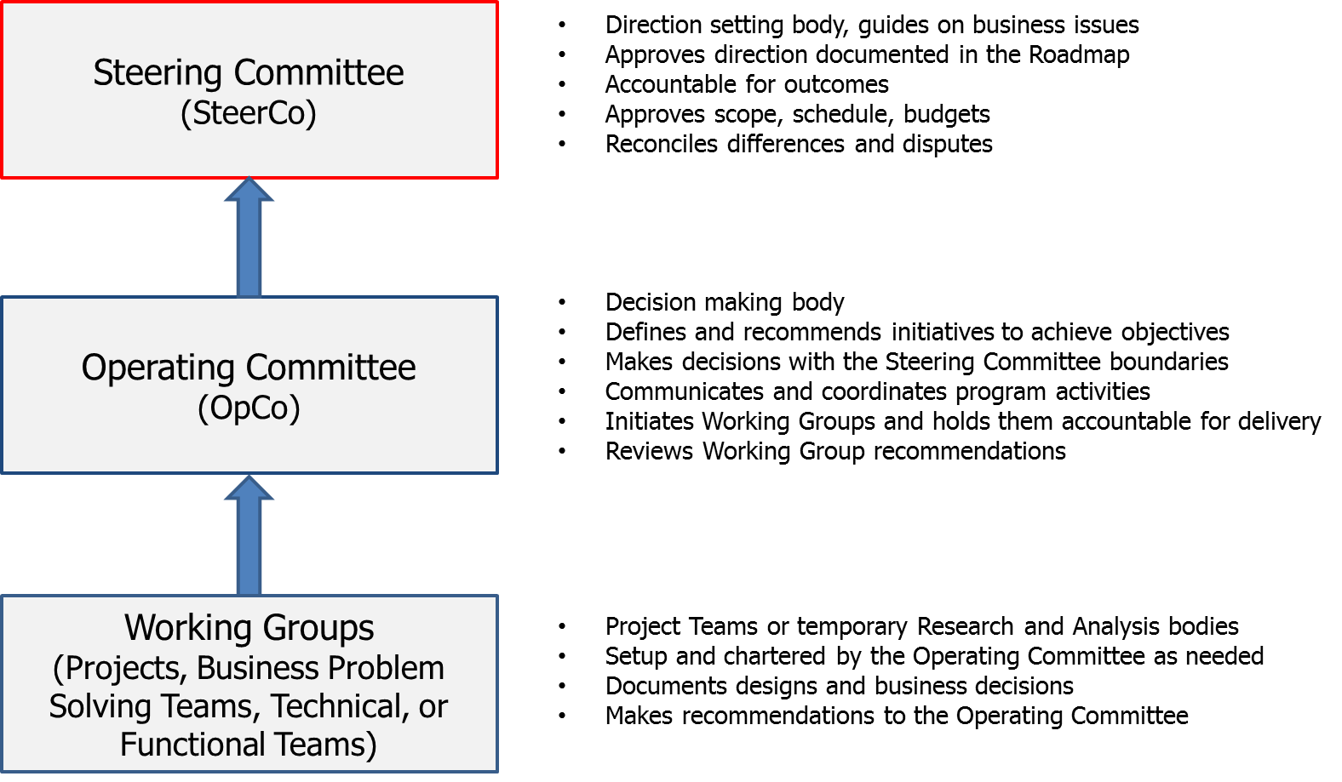

The project is governed by the Human Capital Management Steering Committee which represents stakeholders impacted by this initiative. The Steering Committee will provide oversight to the design, implementation and execution of processes and supporting tools. They are empowered to make decisions regarding program scope, allocation of approved budget, and schedules and to resolve escalated issues and risks. The Steering Committee will also address issues which are cross-departmental and enterprise-wide.

The Operating Committee will support program governance through coordination of staffing across work stream activities, research and recommendations for key decisions that require escalation to the Steering Committee, resolution of people, process, and technology issues that cross work-streams, and provide a forum for discussion on change impacts with affected stakeholders.

This project is sponsored at the Executive level by Darren Ruhr, Senior VP Corporate Services.

Project Organizational Structure

Stakeholders
The project stakeholders are the groups or individuals who have a vested interest in the project process or outcome. The purpose in identifying the stakeholders is to ensure that stakeholder expectations are understood and to establish appropriate communication with the stakeholders in order to manage those expectations.
Group/Department | Key Contacts | Interest
Health & Safety | Dan Lundstrom  Jason Tucker | Employee data model changes impacting downstream HSE systems and reporting
Field Training & Development | Steve James  Deric Simmons | Employee data model changes impacting downstream Learning systems and reporting
Personnel | Pat Wagner  Lee-Ann Triffo | Forms, process, data, and reporting changes for Canadian field employees
Global HR | Shellie Stone | Process owner for Global HR Services
Talent Management | Tonia Emery | Employee data model changes impacting Talent Management processes and HR reporting
Organizational Development & Learning | Roy McClung | Employee data model changes impacting Learning systems and reporting
HRIS | Paul Sudzina | Process owner for Employee and Organizational Master Data
Talent Acquisition | Aron Ferchuk | Forms, process, data, and reporting changes impacting organizational management (integrated with SF Recruiting) and Onboarding
Benefits | Jennifer Fox | Forms, process, data, and reporting changes impact Benefits Management
Compensation | Jennifer Fox | Forms, process, data, and reporting changes impact Compensation Management
Payroll | Karen Kerkhoff | Forms, process, data and reporting changes impacting downstream Time Capture and Payroll Processing
IT Enterprise Service Delivery | Janine Maynard | Impacts of changes to the onboarding and off boarding processes
IT SAP Delivery | Cledwyn D’Silva  Wilson Yung | Delivery of sustainable solutions that will be transitioned to IT SAP Delivery for ongoing operational support
IT Business Systems Integration – FI & OPS | FI – Chris James  OPS – Robert Koss | Integration impacts with Finance & Operations; design decision and resourcing support cross streams; support engagement of business leadership within Finance and Operations
Finance Operations Business Systems | Christopher Ames | Alignment of organizational structure with financial data structures (i.e. cost centres)

Risk Management
Risk | Probability | Severity | Management Plan
Budget | M | H | Continuous improvement approach enables scaling delivery based on available funding
Uncommitted/unavailable business resources leads to an inability to plan and execute | M | H | Steering Committee will communicate program priorities and identify strong business representation. Backups will be identified and informed for coverage.  Proactive planning to balance workload of ongoing support activities and program deliverables. If the scope of SAP enhancements is larger than originally estimated additional consulting support will be required
Stakeholder Groups Not Engaged | H | H | Ensure primary stakeholders attend and participate in workshops/meetings. If stakeholder groups were missed, review work completed to ensure alignment. Escalation to the Steering Committee where required.
Scope Creep | H | H | Clearly defined business objectives, scope, and constraints must be identified to ensure we have a clear and consistent understanding of what ‘done’ looks like
Interdependencies with other roadmap/improvement programs | H | H | Broad communication of the broader Program roadmap, understanding the linkages to all other process initiatives
Stakeholders do not agree on the design for the processes or tools | M | H | Ensure roles and responsibilities for the Steering Committee are understood. Establish process to manage issues where they are elevated i.e. Executive Sponsor makes final decision.
Cultural Change | H | H | Need buy in and commitment to support change management

Budget and Plan

Estimated Budget
Phase | Budgeted Effort  (Person Days) | Total Cost | Budgeted  Labor | Contingency | Licensing | Travel Expense
Assessment | 201 | $142,398 | $112,520 | $16,878 | $0 | $13,000
Analysis & Design  Development & Deploy | 301.5 | $300,724 | $239,760 | $35,964 | $0 | $25,000
Deliver & Close | 12.5 |  | $12,000 | $1,800 | $0 | $3,000
TOTAL | 457 | $459,922 | $364,280 | $54,642 | $0 | $41,000

High Level Project Milestone Plan
Milestones | Target Date
Project Initiation (Charter, Plan, Budget) | January 15, 2015
Funding Secured & Resources Onboarded | March 1, 2015
Centralize
Canada & US | January 1, 2015
International (milestones for International to be added once centralization model is defined) | April 1, 2015
Standardize
Initial Impact Assessment | February 27, 2015
Master Data Team Process Improvement Kickoff - Canada | March 2, 2015
Formal Process Assessment - Canada  Interviews, Observation, Data Analysis & Tracking | March 20, 2015
Begin Pain Point Prioritization (Iterative) | March 27, 2015
Master Data Team Process Improvement Kickoff - USA | April 6, 2015
Begin AS IS Process Documentation | April 6, 2015
Complete Reporting Assessment (KPI’s & Metrics) | April 15, 2015
Begin Implementation of Quick Wins | April 20, 2015
Complete Formal Process Assessment - USA  Interviews, Observation, Data Analysis & Tracking | May 4, 2015
Complete Pain Point Prioritization (Iterative) | May11, 2015
Complete AS IS Process Documentation | May 31, 2015
Begin Implementation of Larger Initiatives | June 22, 2015
Complete Standardization | August 30, 2015
Automation
Assess Tools
Prototype Automated Data Capture | June 30, 2015
Prototype Automated Data Upload to SAP | July 31, 2015
Begin Production Deployment of Automation Tools | September 1, 2015
Project Closure | November, 2015

High Level Project Roadmap

Activity | 2014 | 2015
Activity | Q4 | Q1 | Q2 | Q3 | Q4
Centralize
Planning
Execute Centralization
Standardize
Part 1 – Global Master Data Design
As Is Process Documentation
Identify Pain Points & Prioritize
Process Improvement Assessment – Develop To Be
Part 2 – Global Master Data Implementation
Implementation of Quick Wins/Short Term Improvements
Implementation of Longer Term Improvements
Automation
Automate Data Capture, Validation, and Processing
H2R Learning
Develop EE Lifecycle Learning Materials & Delivery

